What is a good one word descriptor for the word Renaissance?

rebirth

What was a major reason the Renaissance began in Italy?

Italian city-states had grown wealthy from trade between Europe and Asia

Why did the Renaissance occur in northern Europe later than it did in Italy?
The Black Death delayed economic growth in northern Europe
The development of printing in Europe led to.
Increased literacy. Humanistic Ideas

The artists of the Renaissance focused on
Humanistic concerns.

Use the pictures below to answer the following question
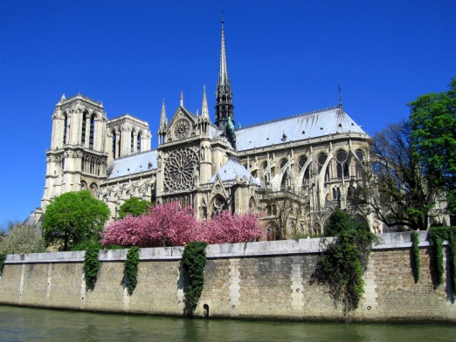
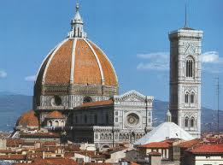

In what ways did Renaissance architecture differ from the architecture of the Middle Ages?
Renaissance architecture borrowed more from classical styles

Why was Martin Luther was dissatisfied with the church?

Disagreed with the sale of indulgences

What did Luther believed in…
Salvation could be achieved through faith alone

- Sale of indulgences authorized by pope Leo X to raise money to build St Peter's Basilica in Rome (1515)
- Ninety-five Theses posted (1517)
- Hearing held at Worms, Germany

What are these events related to?
Martin Luther and the Protestant Reformation
Improved cartography
Improved lines of latitude and longitude
Astrolabe
caravel

What do these four factors have in common?
They all made exploration easier
The transfer of disease was most deadly to the native peoples of?
Americas

List the advances made during the Age of Exploration?
Advances in learning and technology made long ocean voyages possible

How did the Europeans justify taking lands from the Native Americans?
Introducing them to Christianity

What are the "3G's" motive for exploration?

G-d, Glory, Gold
“By the mid-16th century, Johann Gutenberg’s invention of the printing press revolutionized the world, making the printed word accessible to the literate public.”
How did the printing press impact globalization during European exploration of the new world?
Maps and letters from explorers were distributed to the public, increasing interest in the new world

Why was the Encomienda system a failure?
Enslaved people from West Africa took the place of Native Americans who died of disease

What did the the Treaty of Tordesillas do?(1494)
Divided each area into European-controlled segments
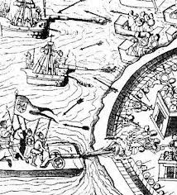

Explain the Spanish conquest of the Aztec Empire using this illustration.
Spanish technology was a major factor in the defeat of the Aztecs

In Latin America during the early period of Spanish colonialism, the deaths of large numbers of the native people led to:
the importation of slaves from Africa

What was an immediate result of the European Age of Exploration?
European influence spread to the Western hemisphere

What system developed as a result of the Commercial Revolution:
market economy

What was a major result of the Commercial Revolution?

Expansion of European influence overseas
“God hath power to create or destroy, make or unmake, at his pleasure; to give life or send death; to judge…and to be judged (by) none…And the like power have kings;…”

Which idea is described by this passage?
theory of divine right

The Edict of Nantes allowed for which group to keep their religion and fortify their towns in France?
Huguenots
Following the Glorious Revolution, the English Bill of Rights affirmed the principle of _______________________ meaning no person could be held in prison without being charged with a crime.
habeas corpus
Which leader imposed a beard tax on his nobles if their beards weren’t shaved? His goal was to westernize Russia.
Peter the Great
Speaker A: Although I spread serfdom in my country, I tried to modernize our society by adopting aspects of western technology

Speaker B: I promoted culture with my support of the arts. Unfortunately, I drained my country's treasury by building my palace at Versailles and involving my country in costly wars.

Speaker C: I gained much wealth from my overseas empire in the Americas. I waged war against the Protestants and lost.

Speaker D: I inherited the throne and imprisoned my foes without trial. I dissolved Parliament because I didn't want to consult them when I increased taxes.
Which speaker represents the views of King Louis XIV?
Speaker B

Which nation was most likely governed by speaker D?
England

Which type of government is most likely associated with all of these speakers?
Absolute Monarchy
Which sources of knowledge were most central to the Scientific Revolution?
Observation and experimentation
What was Copernicus’ main proposal about the earth and sun?
Earth Traveled Around the Sun
What idea by Newton linked motion in the heavens with motion on the earth?
Law of Gravity
Speaker A: Good government stresses the importance of the nation and accepts the rights of the individual only if the interests of the individual are the same as those of the nation.

Speaker B: The person of the king is sacred and to attack him in any way is to attack religion itself. The respect given to a king is religious in nature.

Speaker C: All human beings are born free and equal with a right to life and liberty. It is the duty of government to protect these natural rights of its citizens.

Speaker D: Our goal will not be achieved by democracy or liberal reforms, but by blood and iron. Only then will we be successful. No nation achieves greatness or unity without the traumatic experiences of war.

Which speaker’s statement best reflects the ideas of the Enlightenment?
Speaker C

What was Enlightenment thinker Baron de Montesquieu’s idea about government powers?
Separation of Powers

“We hold these truths to be self-evident: that all men are created equal, that they are endowed by their creator with certain unalienable rights, that among these are life, liberty, and the pursuit of happiness.”

The ideas expressed in the quotation are based primarily on the writings of:

John Locke

What event had the greatest influence on the Enlightenment ideas of natural law and reason?

Scientific Revolution

The writers and philosophers of the Enlightenment believed the government decisions should be based on:
Law of Nature and Reason

How did Enlightenment philosophers interpret the divine right of kings?
the power of the government is derived from the governed

A study of revolutions would most likely lead to the conclusion that Pre-Revolutionary governments?
Fail to meet the political and economic needs of their people.

What was the most famous and effective way for the colonies to protest British taxation?

Boycotting British goods

Why was the phrase “taxation without representation” so important to the revolutionary cause?
Colonists did not wish to support a government in which they had no voice.

What war caused the British Government to apply the Stamp Act to the colonies?
French and Indian War

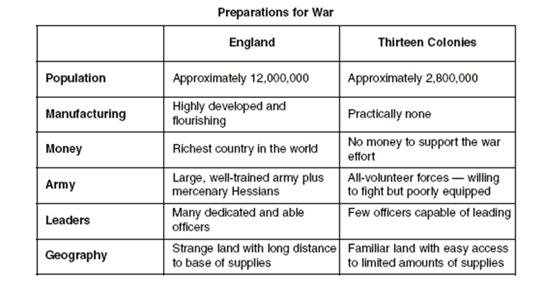

What conclusion about the American Revolutionary War can be determined by information in this chart?
The thirteen colonies had few, but important advantages in the war with England

Describe one way that the American and French revolutions were different?
American revolutionaries overthrew a distant oppressor; French revolutionaries overthrew their own social order

What were the causes of the French Revolution?
A failure to reach compromise by the first and second estates
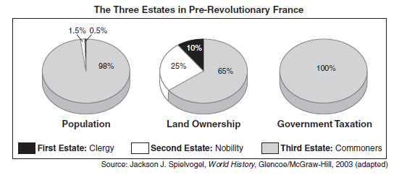

Based on these circle graphs, describe the inequality amongst the social classes.
The First and Second Estates had landholdings out of proportion to their size.

What contributed to France’s financial crisis?
bad harvests, famine, and increase in bread prices

Who became the prominent figure of the revolution, the creator of the French republic, the leader of executions of those against the revolution (reign of terror)?
Maximillen Robespierre

During the Reign of Terror, Robespierre tried to:
crush all opposition to the revolution.

How did the Napoleonic Code reflect Enlightenment principles?

It guaranteed the equality of all citizens before the law

One similarity in the actions of Simón Bolívar and Napoleon Bonaparte is that both leaders
Encouraged nationalism

Which of the following became an important source of power for the Industrial Revolution?
The steam engine

What helped British farmers increase food production in the 1700s?
Improving farm machinery.

Why did Britain take the lead in the Industrial Revolution?
The British business class had capital to invest in.

What did Industrialization in the textile industry result in?
The establishment of factories

What condition is most necessary to the process of industrialization in a society?
availability of investment capital

Describe conditions of workers in mines and factories during the early Industrial Revolution.
Their working conditions were dangerous and inhumane.

What effect did urbanization have on the working class?
It forced them to live in filth.

Before a nation can begin to industrialize, that nation must first develop-
An adequate food supply.

What belief was part of strict laissez-faire economics?
Govt. should not interfere in the economy

Socialists and communists believe in a society without what?

Classes of People
According to Karl Marx, history is the record of the:
Struggle between classes in society

“A country is not merely a geographic territory. A country is also the idea given birth by the geographic territory. A country is a sense of love that unites, as one, all the sons and daughters of that geographic territory…”
--World History: A Story of Progress

What is the main idea of this quotation?
Nationalism

What was used as a justification for imperialism?
Westernization

Nationalism is most likely to develop in an area that has:
Common customs, language, and history

How did the Industrial Revolution encourage imperialism?
It created a need for raw materials and markets

World War I had 4 MAIN causes, they are:
militarism, alliances, imperialism, nationalism

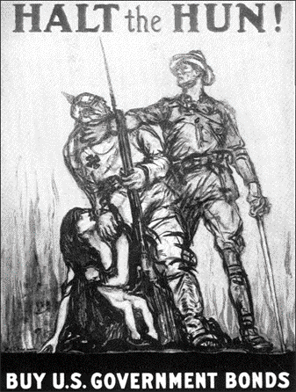

Figure 27-1

69. What best describes how the Germans are portrayed in the figure?
as cruel barbarians

Why was the Balkan region referred to as the “Powder Keg of Europe” prior to World War I?

Nationalistic and imperialistic rivalries were increasing.

I am glad you are back. In this most serious moment, I appeal to you to help me. A….war has been declared on a weak country [Serbia]. The resentment in Russia, shared fully by me is enormous. I foresee that soon I will be fully overwhelmed by the pressure upon me and be forced to take extreme measures that will lead to war. I beg you to do what you can to stop your allies from going too far.
Nicholas II (Russai) Telegram to Wilhelm II (Germany) July 29, 1914

What conclusion can be supported by this telegram?

Nicholas II hopes diplomacy can prevent war

Why was it difficult to gain an advantage over the enemy in trench warfare?
The machine gun made it nearly impossible for troops to advance.

What was Germany’s all-out battle strategy in WWI against Entente forces of France and Russia?
Schlieffen Plan

From 1914 to 1916, as World War I raged in Europe, Americans were not able to remain neutral in thought as well as action mainly because:
the warring powers interfered with the United States right to freedom of the seas

Describes the relationship between World War I and the Russian Revolution?
World War I created conditions within Russia that helped trigger a revolution

During the Russian Revolution of 1917, the slogan "Peace, Bread, and Land" appealed to many Russian peasants because it:
Addressed their desires for their own land and peace

What was the major impact of the Treaty of Versailles on Germany ?
An increase in Germany’s desire to regain its power and prestige

Whose involvement changed the course and outcome of World War I?
American military and ﬁnancial intervention in the war

During World War I, many American women helped gain support for the suffrage movement by:
Working in wartime industries

The harsh conditions imposed by the Treaty of Versailles after WWI helped lay the foundation for?
Rise of Nazism in Germany

What was a major factor causing people in Europe to question their new failing governments following WWI and eventually cause the rise of dictators?
The Great Depression

Fascism in Europe during the 1920's and 1930's can be best described as:

A political system that glorified the nation above the individual

Use of violence and terror censorship
________?_________
Blind loyalty to a leader extreme nationalism

Which ideology best completes the graphic organizer?
Fascism

What was one reason why totalitarian dictatorships gained power in Europe between WWI and WWII?
New democracies failed to meet the demands of the people

In the 1930’s, the United States attempted to avoid a repetition of the events leading up to United States involvement in World War I by:
Passing a series of neutrality laws

What did Japan's invasion of Manchuria, Italy's attack on Ethiopia, and Germany's blitzkrieg in Poland have in common?
They were examples of military aggression/expansion

Japan invades China
The Rome-Berlin-Tokyo axis is formed
Japan resigns from the League of Nations

?
U.S. places embargo on scrap iron and oil exports to Japan

Which is the next to occur in the series of events?
Pearl Harbor was attacked by Japan

Nazi Rise to Power

Based on the information in this diagram, what gave rise to Nazi power in Germany?
Political and economic instability

Describe One similarity between Adolf Hitler and Benito Mussolini.
Glorified violence

Describe Germany during the rise of WWII?
A strong economic nation

"In this period my eyes were opened to two menaces which I had previously scarcely known, and whose importance for the existence of the German people I didn't understand: Marxism and Jewry. Once, as I was strolling through the city, I encountered a figure in a black caftan and black hair. Is this a Jew?... The longer I stared at this foreign face, scrutinizing its features, the more my first question assumed a new form: Is this a German? In a short time I was made more thoughtful than ever by my rising insight into the activity carried on by the Jews in certain fields. Was there any form of filth…particularly in cultural life, without at least one Jew involved in it?"
-adapted from Adolf Hitler's, Mein Kampf

What was a direct effect of the prejudices expressed in this passage?
Millions of European Jews, including children, were murdered during the Holocaust

Which speakers hold the view that using the bomb was an appropriate military action?
Speaker A: “The use of the bomb shortened the war and saved American lives.”
Speaker B: “The United States might have been able to force the Japanese to surrender
simply by demonstrating the power of the bomb on a deserted island.”
Speaker C: “The use of the bomb was justified because of the Japanese attack on Pearl Harbor.”
Speaker D: “In Hiroshima, the bomb instantly incinerated more than 60,000 people. Most were civilians.”

A and C

During World War II, many women experienced a change in role in that they:
Worked in jobs formerly held by men

In the period following World War II, the United States established a long-term military presence in West Germany in an effort to:
Stop communist expansion in Europe

What is One reason the Soviet Union formed the Warsaw Pact?
Limit the threat of invasion from Western Europe

What did the expansion of communism into Eastern Europe result in?
WW2

During the Cold War Era (1945-1990), the United States and the Soviet Union were reluctant to become involved in direct military conflict mainly because of:

. Blockade of Berlin
· Operation of the Berlin Airlift
· Organization of the Warsaw Pact
· Construction of the Berlin Wall

The potential for global nuclear destruction

Describe the major events of the Cold War.
Situations that increased tensions between communist and democratic nations in Europe

“From Stalin in the Baltic to Trieste in the Adriatic, an Iron Curtain has descended across the continent. Behind that line lie all the capitals of the ancient states of Central and Eastern Europe. Warsaw, Berlin, Prague, Vienna, Budapest, Belgrade, Bucharest and Sofia, all these famous cities and the populations around them lie in what I might call the Soviet Sphere, and all are subject, in one form or another, not only to Soviet influence, but to very high, and in some cases increasing measure of control from Moscow."
-Winston Churchill
What is the main idea of this quotation?
The Soviet Union has expanded its influence throughout Eastern Europe

What was the primary reason for U.S. involvement in East Asia during the early 1950s?
North Korean attempts to unify the peninsula challenged the U.S. policy of
Containment.

