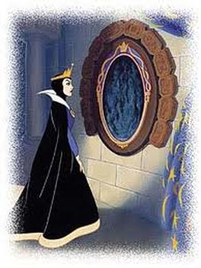
Mirror, mirror on the wall, who’s the Absolutist of them all?

Using information about your Monarch from your textbook or EDUCATIONAL WEBSITES (not Wikipedia), create a poster to defend your ruler from naysayers, and promote his or her right to power. By creating the poster, you should have a pretty good idea of what life under this monarch was like.

Items to include in your poster:

- any learning targets that relate to your monarch
- a picture of your ruler
- map of their nation (during their ruling time period)
- Campaign slogan for the monarch *creative and catchy*
- Their political viewpoints and agenda
- Goals and accomplishments
- How the monarch controlled their:
  - Nobility
  - Peasantry
  - Military
  - Religion
  - Tax and spending

- Philip II
- Louis XIV
- Charles I
- Oliver Cromwell
- William and Mary
- Peter the Great
- Catherine the Great

