European Exploration
Academic Vocabulary
3G Theory- G-d, Glory, Gold. Theories used to justify the Expansion of Europe to Western Worlds.

Cartographer- Map Maker

astrolabe- Calculated the time and the position of the Sun and stars in the sky

caravel- is a small, highly maneuverable sailing ship developed in the 15th century by the Portuguese to explore along the West African coast and into the Atlantic Ocean

scurvy- Lack of Vitamin C causing general weakness, anemia, gum disease, and skin hemorrhages

circumnavigate- sail all the way around (something, especially the world).

Line of Demarcation- Agreement between Spain and Portugal dividing control of Western hemisphere.

Manchu conquest-

Chinese response to westerners- China Isolated themselves refusing to open their economy to the West.

conquistador- Term given to Spanish and Portuguese conquerors of the western world.

plantation- large piece of land where one crop is specifically planted for widespread commercial sale and usually tended by resident laborers.
encomienda- Permission from Spain to demand tribute and forced labor from the Indian inhabitants of an area.

missionary- a person sent on a religious expedition to convert local inhabitants.

revenue- income that a business has from the sale of goods and services to customers

Mayflower Compact- First governmental document signed by Plymouth Colonists.

1763 Treaty of Paris- Great Britain, France and Spain, with Portugal in agreement, after Britain's victory over France and Spain during the Seven Years' War

triangle trade route- 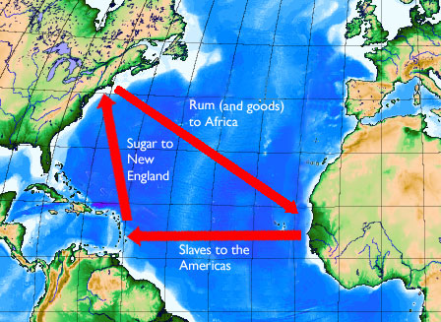

repeal- revoke or annul a law of governmental act.

monopoly- One company is the sole provider of a particular good or service

inflation- sustained increase in the general level of prices for goods and services.

entrepreneur- a person who organizes and operates a business or multiple businesses

joint stock company- a business where different stocks can be bought and owned by shareholders

mercantilism- a system in which a country attempts to amass wealth through trade with other countries, focus on export rather than import.

tariff- is a tax on imports or exports

Columbian exchange- Exchanges of plants, animals, diseases and technology between the New and Old Worlds

