THE LEGACY OF THE TRANSATLANTIC SLAVE TRADE ON AFRICA:

Encouraged African Warfare. | Disrupted African Culture. | Increased Cultural Diffusion.
The slave trade encouraged tribes to go to war with each other to obtain slaves to trade for European textiles, metalwork, guns, gunpowder, tobacco, rum, and other goods. | The slave trade destroyed much of African’s rich heritage and disrupted its development. It created a legacy of violence, bitterness, and social upheaval. | The exchange of ideas and goods increased. Slave traders brought new weapons and other goods to Africa, while slaves brought their beliefs, legends, and music to the Americas.
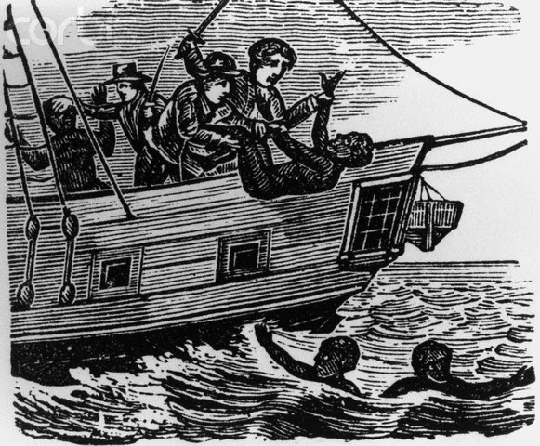

ACTING AS AN
AMATEUR HISTORIAN:

Rufus Clark in his book, The African Slave Trade (1860), described the conditions of the “Middle Passage”:

“They came swarming up, like bees from the opening of a hive, till the whole deck was crowded to suffocation, from stem to stern. After enjoying for a short time the unusual luxury of air, some water was brought; it was then that the extent of their sufferings was exposed. They all rushed like maniacs towards it. No threats or blows could restrain them; they shrieked, and struggled, and fought with one another for a drop of this precious liquid. There is nothing from which slaves, in the Mid-passage, suffer so much, as want of water. When the poor creatures were ordered down again, several of them came and pressed their heads against our knees, with looks of the greatest anguish at the prospect of returning to the horrid place of suffering below.”
- What can we learn from this description of the “Middle Passage”?
______________________________________________________________________________________________________________________________________________________________________________________________________________________________________________________________________________________________________________________________________________________________________________________________________
- What would you have done to survive the “Middle Passage” to the Americas?
_____________________________________________________________________________________________________________________________________________________________________________________________________________________________________________________________________________________________________________________________________________________________________________________________________
Learning targets exercise/Directions: Match the key term with its description. Information for each key term can be found in pages 400-402 of your textbook.

A. African leader’s resistance/Repeal
B. The Asante Kingdom/Monopolies
C. Islamic Crusades/the Fulani and Hausa People
D. The Dutch Boers
E. Shaka and the Zulus
F. Boers versus the Zulus

1. C. In the 1700s and early 1800s, an Islamic revival spread across West Africa. It began among the Fulani people in northern Nigeria under the scholar and preacher Usman dan Fodio who denounced the corruption of local Hausa rulers. Usman called for social and religious reforms based on the Sharia, or Islamic law. He also encouraged Fulani herders and Hausa townspeople to rise up. Usman and his successors set up a powerful Islamic state under which literacy increased, local wars quieted, and trade improved. Their success inspired other Muslim reform movements in West Africa.
2. E. In the 1800s, Zulu’s who had migrated into southern Africa in the 1500s, emerged as a major force under a ruthless and brilliant leader, Shaka. Shaka waged relentless war and conquered many nearby peoples. Conquered groups who had assimilated into the Zulu kingdom then migrated north, conquering other peoples and creating their own powerful states.
3. B. In the late 1600s, officials chosen by merit rather than by birth supervised an efficient bureaucracy within the Asante kingdom under divine ruler Osei Tutu. They managed the exclusive control of a business or industry trading with Europeans on the coast, exchanging gold and slaves for firearms.
4. D. In 1652, Dutch immigrants migrated into southern Africa. They built Cape Town to supply ships sailing to or from the East Indies. Dutch farmers settled around Cape Town. Over time, they ousted or enslaved the Khoisan herders who lived there. They held to a Calvinist belief that they were the elect, or chosen, of God and looked on Africans as inferiors.
5. A. In the late 1700s, the sea captains and local chiefs protested, and called the almany of Futa Toro in north Senegal to cancel the law he had prior put in place, which forbade anyone to transport slaves from Futa Toro for sale abroad. The almany’s refused but his victory was short-lived, however. The inland slave traders simply worked out a new route to the coast.
6. F. In 1815, the Cape Colony passed from the Dutch to the British. Many resented British laws that abolished slavery and otherwise interfered in their way of life. To escape British rule, Thousands of families joined a “Great Trek” north where they came into contact with Zulus. Fighting broke out and Zulu spears could not defeat Boer guns. The struggle for control of the land would rage until the end of the century.

