Causes of WWI
M – Militarism
A – Alliances
I – Imperialism
N – Nationalism
- Nationalism
- Imperialism
- The Alliance System
- Militarism

- The Assassination of Archduke

Nationalism
- Nationalism means being a strong supporter of the rights and interests of one’s own country.
  - This can be good and bad.

Italy and Germany
- During the Congress of Vienna (the meeting to put Europe back together after Napoleon was put into exile), the countries of Britain, Austria, Prussia and Russia created a new Europe that left Germany and Italy divided and basically getting the raw end of the deal.
  - Strong nationalist movements led to the reunification of Italy (1861) and Germany (1871)

France
- France lost land to Germany at the end of the Franco-Prussian War, which left nationalist groups in France dead-set on getting that land back.

Austria Hungary & Serbia
- There were opposing nationalist groups within these countries and each one wanted their own land and government.

Imperialism

- Imperialism is when a country takes over new lands or countries and then subjects the people to its rule.
  - The rise of Industrialism meant that countries needed new markets to get resources from and sell their goods.
- Britain, France, and Germany had growing rivalries with each other over who ruled the lands in Africa. They quickly tried to claim the land for themselves (this is known as the Scramble for Africa)
Alliances

- An alliance is an agreement made between two or more countries to give each other help (financially, militarily, and through goods and services) when they need it.
  - When an alliance is signed, those countries become known as allies.

- There were many alliances made between the years 1879 and 1914
  - These alliances were important to causing WWI because they meant that many countries had no choice but to declare war if one of their allies did first.
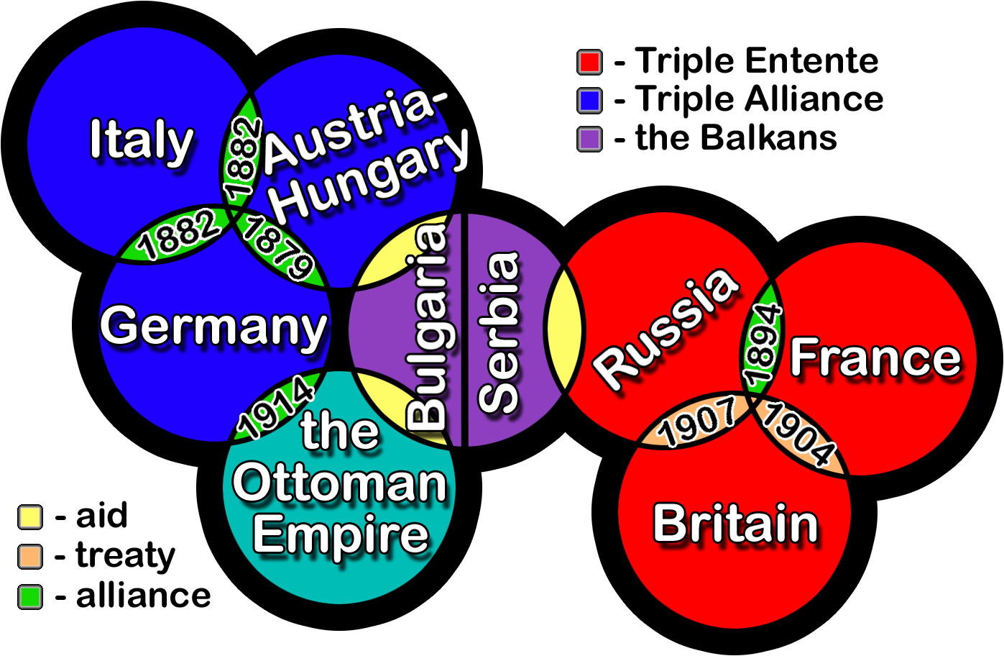

Militarism

- Militarism is when a country or government places high importance on military forces.
- Building many weapons
- Enlisting many soldiers

- Tensions that were growing in Europe led to an arms race (building more weapons than the enemy)
- French and German armies doubled between 1870 and 1914
- Britain and Germany were competition with each other for who controlled the seas (invention of battleships)
- Countries began laying out war plans and maps of where to attack.
Assassination

- The short-term cause of WWI was the assassination of Austrian archduke Franz Ferdinand and his wife on June 28th, 1914.
  - Ferdinand was the heir to the Austria-Hungarian throne.
  - He and his wife were murdered in Sarajevo, Bosnia by a Serbian Nationalist, Gavrilo Princip, who worked for an organization known as the Black Hand.

- Immediately following the assassination Germany pledged its full support to Austria-Hungary and pressured them to declare war on Serbia.
  - France strengthened its backing of Russia.
  - Austria-Hungary was convinced that the Serbian government was behind the assassination and issued Serbia an unacceptable ultimatum, and Serbia agreed almost entirely.

The Domino Effect

- Austria-Hungary still wasn’t satisfied, and declared war on Serbia on July 28, 1914
  - Russia, in support of their Allie Serbia, declares war on Austria-Hungary
  - Germany declares war on Russia, and two days later on France.
  - Germany’s invasion of Belgium (who declared it was neutral) to attack France, leads Britain to declare war on Germany.
  - Thus, WWI had begun.
