What was the main goal of the Vikings?

How did Clovis gain the support of his people?

How did Charlemagne briefly unite much of Western Europe?

What were the achievements of the Carolingian Empire?
-

-
What led to the Downfall of Charlemagne?

What is the manorial system?
-

-
What is the economic structure of the manor?

Define fief:

How is that different from a manor?

What were some new agricultural practices developed in the Middle Ages, and how did they impact society?

What is feudalism?

Who is responsible for spreading feudalism in Europe after the Battle of Hastings?

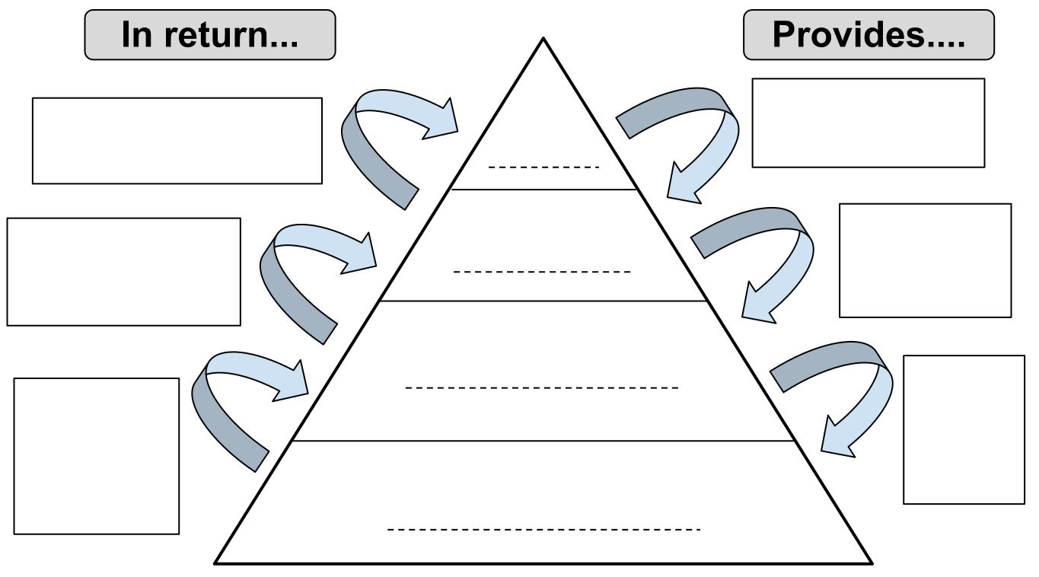
Why would a peasant agree to give crops to a lord – what did he get out of it?

How did the church shape medieval society?
-

-
List the powers the church had at its height in power.
-

-

Describe the relationships between the monarchs and church.
-

Define
lay investiture –

excommunicate -

interdict –

What were 2 instances of power struggles between the church and state?
-

-

What are the lasting effects of the Crusades?

What impact did the crusades have on Europe?

What are the lasting political effects of King John?

Why is the Magna Carta an important document?

What led to the great Schism?

Describe the Holy Roman Empire.

Describe the Byzantine Empire.

What are 2 characteristics of Medieval architecture?

What led to the spread of the bubonic plague?

What were 2 characteristics of the Golden Age of Islam?
-

-

Who is Mansa Musa, and why is he an important historical figure?

How did travel and trade after the Crusades impact Europe and the Middle East during the Middle Ages?

