King John and the Magna Carta

- Events leading to the creation of the Magna Carta
  - 1066 Norman conquest of England
  - By 1199 English king most powerful in Europe
    - Due to:
      - Sophisticated centralized government

      - Extensive ______________________ land holdings in Normandy

King John of England
- Younger brother of King __________________
  - No set rules to define line of succession
  - Richard left to fight in the 3rd crusade
  - Early 13th century John was crowned King of England instead of Richard’s son, Arthur
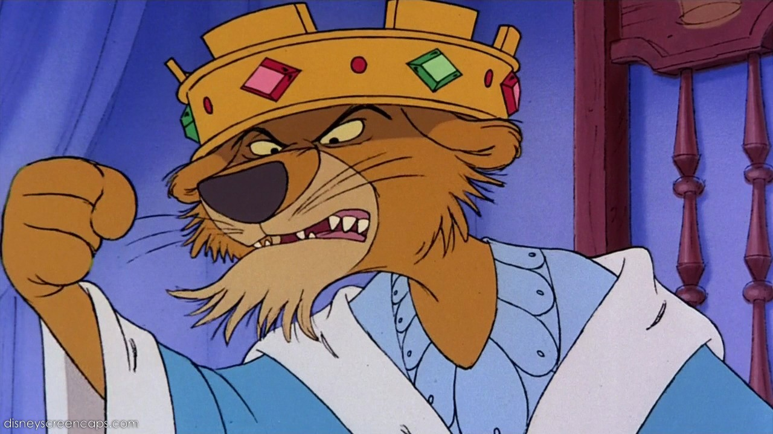
- Described by historians as:

  - Clever
  - Greedy
  - Cruel
  - Untrustworthy
  - Weak military leader

King John’s reign of troubles
- Three powerful enemies

  - King Phillip II of __________________
    - 1205 lost war to King Phillip
    - Gave up English-held lands in Anjou and Normandy

  - ___________Innocent III
    - Disagreed as to how the Archbishop of Canterbury was to be elected

    - ___________________ King John in 1209
  - English nobles rebelled

Rebellion
- King John angered his ________________
  - Oppressive taxes

    - Increased taxes to pay for armies
    - Imposed the first income tax

  - Other abuses of power
- Nobles forced King John to sign _____________________ on June 19, ______
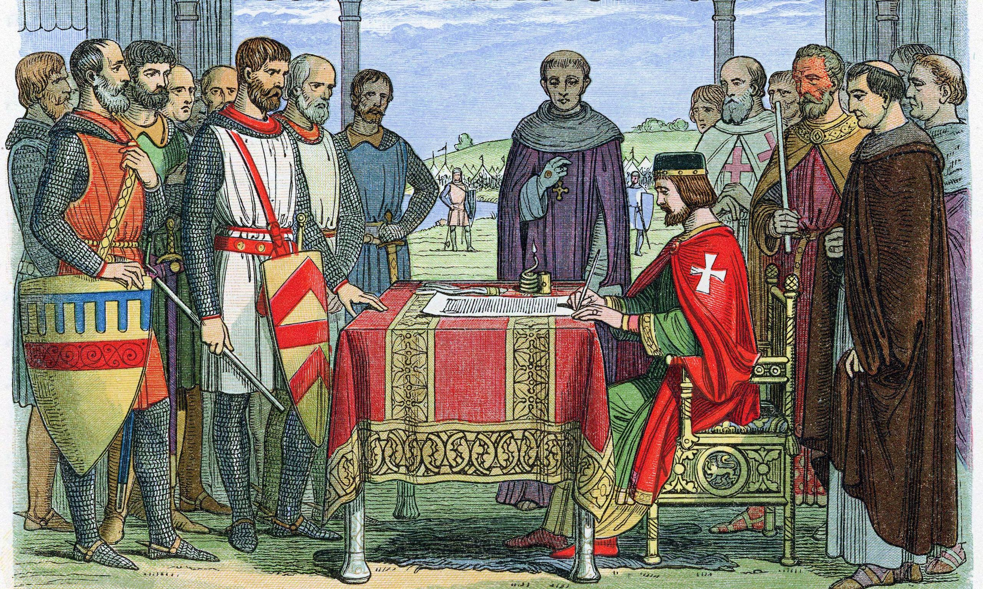
Magna Carta
- Originally written in ___________
  - Written because of disagreements between the Pope, King John and his English barons
    - About the rights of the King

- Misconceptions:
  - the first document to limit power of an English king by law
  - in practice limited power of the king
  - is a single static document

Why was Magna Carta so important?
- King John I forced to accept it.
- A list of demands made by the nobility.

- Created a _______________________ between the king and the aristocracy.

- Established principles which limited the power of the king:
  - Established basic legal rights.
  - The king must ask for popular consent for __________________.

  - Accused must have ______________________

1215 barons had enough & listed their _________________________
- List became known as Magna Carta (Great Charter)
- John met barons at Runnymede
- It introduced the idea that even the king must obey some laws!

Examples of Terms included in the Magna Carta

- The king must not interfere with the Church
- When a baron inherits land he should pay the king no more than £100
- The king cannot collect new taxes unless the barons and bishops agree
- No freeman can be put in prison without trial by a jury
- Justice will be without delays or bribes
- Traders must be able to travel freely without having to pay tolls
- The King’s men must not take anyone’s goods without paying for them.
- As soon as peace is restored, all foreign merchants should leave the country.

Legacy of the Magna Carta

- The right of __________________________
  - You cannot be imprisoned without being charged for a crime
- Guarantees a right to due process
  - No Freeman shall be taken or imprisoned….We will sell to no man, we will not deny or defer to any man either Justice or Right.
- Greatly influenced the U. S. Constitution
  - We cannot be punished without a _____________________
  - We cannot be taxed unfairly
  - America included part of MC in its constitution (1776):
    - “No person shall be held to answer for a crime without trial by jury, nor shall their life, liberty and property be taken without following the law”
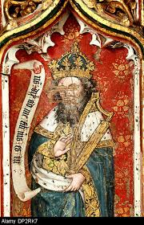
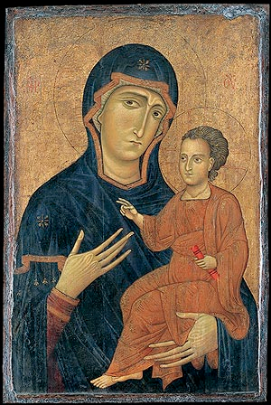

______________________& the Great Schism

- What is an _____________?
  - Sacred images representing the saints, Christ, and the Virgin, as well as

________________________________
such as the crucifixion
    - They appear in several forms; in mural painting, mosaic and most typically painted on small wooded panels.

- Flat 2 dimensional religious images can be recognized in special ways - prayed to and carried in the air in religious processions - and specific technical rules guide their artistic form.

What was the problem?

- Some _____________________ Christians were against icons - they thought it was wrong to worship something that was man- made. Worship should only be made to God.
  - These anti-icon Christians became known as “________________________” - meaning icon smashers
  - Those in favor thought they helped the faithful honor the figures represented.

A Rift Develops
- In 730, Byzantine Emperor Leo III passionately joined the ranks of iconoclasts; he banned icons and ordered all religious images be burned, whitewashed or destroyed.
- Pope Gregory III, favored icons and excommunicated (to kick out of the Church forever) Emperor Leo.

The Great Schism
- After decades of controversy the Byzantines finally accepted icons.
- In 1054 the Christian church split into 2 churches forever.

  - In the ___________; the Roman Catholic (universal) Church.
  - In the East; the Eastern Orthodox (correct belief) Church.

The West – ___________________________________
- All Mass was in Latin
- Clergy were celibate
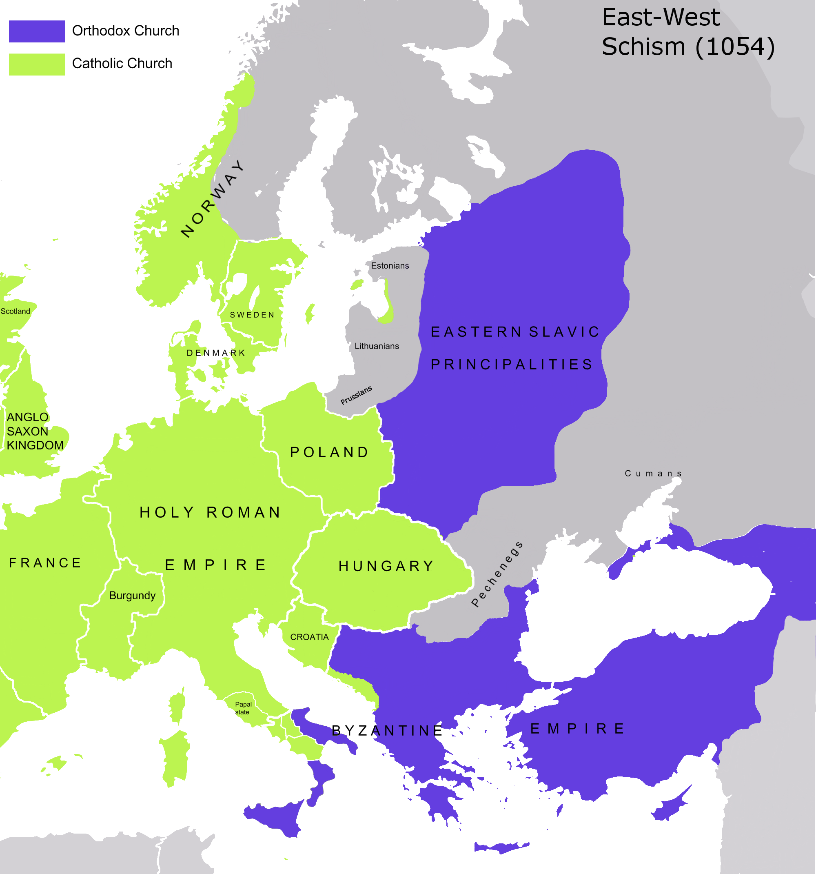
- Religious icons of martyrs and saints to be respected
- Only Pope was Supreme head of Church in the West - above any political ruler
- Pope and Bishops could interpret the scriptures.

The East – _____________________

- “Mass” was in _______________- so everyone could understand.
  - Monks who did missionary work often converted it into the language of the people they were trying to convert
- Emperor was superior to Patriarch of Constantinople.
- Bishops couldn’t marry
  - Other priest didn’t have to be celibate
- Icons caused much controversy - used but disapproved of.

War & Plague: Two of the Biggest Killers in the Late Middle Ages

Bubonic Plague
- Highly contagious bacteria that attacks the immune system causing severe infection.
- Some symptoms can include:
  - chills, fever, diarrhea, headaches, convulsive coughing, spitting blood, swelling of the infected lymph nodes, and black patches on the skin.

Transmission
- The Plague began in _________________ killing an estimated 35 million people and was carried west upon the many trade routes between China and Europe

  - The Plague was carried primarily by rats and ____________ which could jump from person to person, bite them and infect them.

  - Expansive _________________________ and the utter filth of European cities allowed the plague to spread quickly throughout all parts of Europe.

Death Toll

- ____ out of every ___ people died in Europe. (This was about 20-25 Million People)
  - Almost 75 Million are estimated to have died worldwide.
  - There were so many dead bodies in the cities, that many people threw there dead bodies out in the street

Effects of the Plague
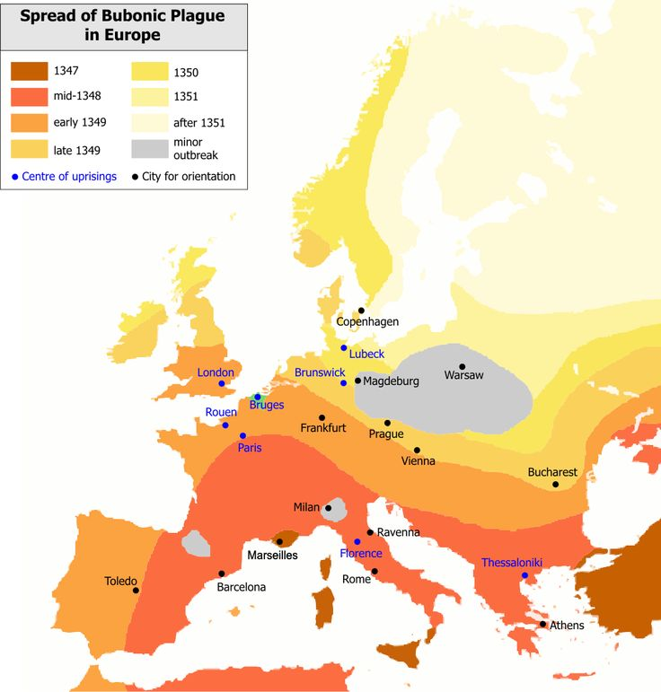
- Merchants died causing ___________ to significantly decline and in turn raised prices
- Workers and employers also die, production declines, prices continue to rise.
    - This all led to
________________________ because their wages are no longer sufficient to live off of.

- The _________________population was blamed for the plague and in some cases they were slaughtered because of it.

- Church’s power was significantly

____________________.
Hundred Years’ War

Yes it lasted for about 100 years. (Approximately 1337-1453)
- It begun when the French king died without a successor and the English king claimed it for himself. (Due to his Norman Heritage)
  - This war was fought on French soil and significantly changed ______________

___________________ and the style of European warfare.

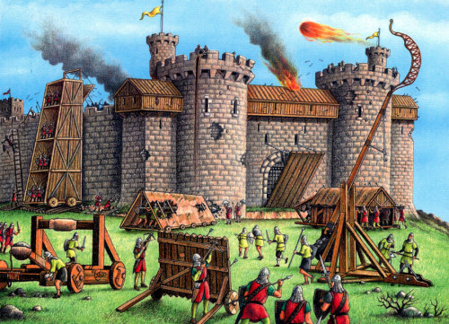
Weaponry
- The English ________________ (6 ft. tall) was introduced during the Hundred Years War and could fire 3 arrows in the time a French crossbowman could fire one arrow.
  - It allowed archers to pierce medieval armor reducing the impact

of mounted ____________ and custom plate armor.

- The __________________ was also introduced at the end of the war and allowed the French to lay siege to and capture most of the English strongholds.

Wars End
- Joan of Arc helped end the war by leading ___________ forces to victory at a fort city near Orleans. This then allowed Charles VII to solidify his position as king of France.
  - Joan of Arc was later captured by the English and burnt at the stake for being a ‘witch’.
  - Her death helped to further motivate the French for she was seen as a ________.

Impact of the War

- A feeling of ______________________ emerged in England and France. People saw the king as a national leader and fought for their country not simply their feudal lord.

- Power and prestige of the French __________________ increased.

- ________________ suffered internal turmoil and wars over the English crown.
- Introduction of new weapons changes the history of warfare.

