The Reforming Tsar: 1698-1725
From the moment of his return from the Grand Embassy, in 1698, Peter makes it dramatically plain that he intends to westernize Russia's hide-bound oriental society and that he will be ruthless in achieving his purpose. He has had to hurry back from his European tour because the streltsy have again attempted an uprising against him.
The rebellion has been easily put down and the culprits are under arrest. Over the coming months Peter takes a personal interest in the interrogation, torture and brutal execution of some 800 rebels. This is his insurance policy against further threats to his rule. His programme of reform will take longer. But it too begins with a dramatic gesture.
The tsar celebrates his first evening back in Moscow with friends in the foreign settlement near Preobrazhenskoe, the village where he has grown up. He then spends the night in a favourite wooden hut from his childhood days, after ordering the leading boyars to attend him there in the morning.
They assemble in their long robes and beards, markedly different in appearance from Peter's own European clothes and shaven face. The beard in particular has been consciously preserved over the years as a symbol of the standards of old Russia. But on this morning the young tsar emerges from his hut with a pair of shears. He cuts a slice from the profuse whiskers of every boyar.
Peter accompanies this assault with a practical measure containing a touch of wit. Anyone who so wishes may remain unshaven. But there is to be a new tax - on beards.
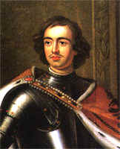
Peter the Great

This symbolic gesture is followed by an extensive programme of practical reform. Never, perhaps, has a ruler so rapidly transformed an antiquated society. Using the absolute power which he has established, Peter introduces new government structures at local and central levels. He replaces a chaotically unreliable army (a militia of noblemen and the professional streltsy) with a large standing force of peasants conscripted for life and properly trained. He creates a naval service and a fleet of warships.
The tsar launches industrial enterprises (as many as 200, for the most part using the labour of state-owned serfs) to develop mines and to build weapons and equipment for his army and navy. Encouragement is given to an entrepreneurial class to set up private commercial ventures.
Education is promoted. Secular schools are founded, for which western texts are translated into Russian. Russians needing specalist skills are sent abroad to learn them in foreign academies. At home professors of mathematics are employed to visit the houses of the gentry, whose sons are not allowed to marry until they attain a certain educational standard. The first Russian newspaper (Vedomosti, 'Records') is published from 1703.
Peter's measures touch all aspects of life. The currency is reformed, as is the Russian script (eight letters are lopped from an unwieldy Cyrillic alphabet). The Russian new year, previously September 1 (supposedly the date of the creation of the world) now becomes January 1. The Christian chronology of Anno Domini is adopted - though Peter's new calendar is less modern than it might be, for he chooses the Julian system rather than the Gregorian reform.
The problem of corruption is tackled by encouraging a pernicious system of informers. But nothing is too small for the tsar's attention. Building and fire regulations are introduced, and one ukase (imperial decree) even orders that crops are to be cut with scythes rather than sickles.
St Petersburg: AD 1703-1712
From 1703 Peter the Great has gratifying evidence of his achievements on behalf of Russia. A great project is taking shape at the mouth of the river Neva, on marshy wooded land which comes into Peter's possession in 1703. Within two weeks of gaining the area he starts to build the Peter and Paul fortress on the right bank of the river; the following year a royal shipyard is founded across the water. The first warship is launched from the yard in 1706.
A town grows rapidly on the site. In 1712 it becomes the capital, named St Petersburg after the tsar's patron saint. Its main street, the Nevsky Prospekt, is built by Swedish prisoners captured in the Northern War.
Peter the Great first intervenes in the Northern War early in 1700, seizing the southern coast of the Gulf of Finland. This territory has belonged since 1617 to Sweden, cutting Russia off from the Baltic. The campaign of 1700 ends ignominiously when the young Swedish king, Charles XII, defeats the Russians at Narva and regains the coastline. But Charles then turns south against other enemies. By 1703 Peter is able to recapture the mouth of the Neva from its Swedish garrison.
In 1707 the Swedish king prepares an invasion of Russia, now plainly emerging as his main rival in the Baltic. This time Peter the Great responds with the classic Russian tactic when Moscow itself is threatened.

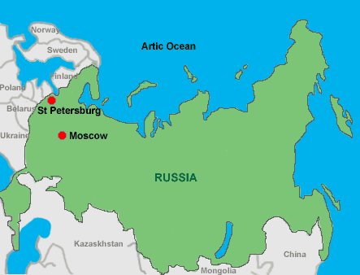
Sweden and Russia: AD 1707-1711
In the autumn of 1707 Charles XII moves northeast from Saxony with an army of almost 40,000 men. His intention is to move towards Moscow during the summer of 1708, forcing Peter to withdraw from the Baltic to defend his capital. The plan is frustrated by Peter's strategy of avoiding a pitched battle while devastating the countryside between the advancing Swedish army and Moscow. By the autumn of 1708 Charles XII is forced to turn south into the Ukraine in search of food.
The winter of 1708-9 is unusually cold even for these inhospitable regions. It is a much reduced Swedish army, of some 18,000 men, which finally comes to grips with the Russians in July 1709 at Poltava.
The engagement is the first major disaster in Charles's brilliant military career. With almost the whole Swedish army either captured or killed, Charles himself escapes south into Turkish territory. He immediately enters negotiations with the Turks, who share his hostility to the Russians and are eager to recover Azov.
Charles summons a new army from Sweden, to provide his share of an anti-Russian alliance with Turkey. It never arrives, but the Turks on their own defeat Peter the Great in 1711 at the Prut river. In the ensuing negotiations Peter agrees to return Azov - and considers himself to have escaped lightly in giving no concessions at all to Sweden, as Turkey's supposed ally.

Seventy years of empresses: AD 1725-1796
It is a remarkable fact that the Russian empire established by Peter the Great is ruled for the next seven decades by women.
The only male emperors in that span are a 12-year-old boy (Peter II, grandson of Peter the Great, enthroned in 1727 and dead three years later); a two-month-old infant (Ivan VI, emperor for a year and then hidden away in prison until his death); and a German prince of feeble mind and body (Peter III, ruling for six months in 1762 before being deposed and murdered).
The reigns of four women span these decades. Catherine I, illiterate but well endowed with common sense and strength of character (necessary qualifications to survive as Peter the Great's intimate companion), has proved her sterling qualities before her reign. But she has only two years on the throne, dying in 1727.
Elizabeth, reigning from 1741 to 1762, brings back the vigorous mood of Peter the Great - appropriately, since she is a daughter of Peter and of Catherine I. Russian interests are now energetically pursued again, particularly in opposition to Prussia in the early stages of the Seven Years' War.
Elizabeth leaves her crown to Peter III, the German grandson of her elder sister. Inheriting early in 1762, he proves totally unsuited to the task. But his wife, a German princess, more than makes up for his inadequacies. Within six months she acquires her husband's throne and before the year is out he is murdered, almost certainly with her connivance. She will rule for thirty-four years, justifiably becoming known as Catherine the Great.
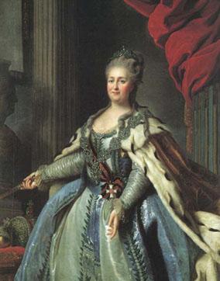
Catherine the Great

Catherine the Great: AD 1762-1796
Catherine is both brilliant and passionate. Her many lovers provide rich material for scandal and gossip in the courts of Europe, and several of her most talented advisers and generals feature in the list. But the programme which they put into effect is hers, as is the interest in political theory and in the advancement of Russia which shapes her policy.
Contemporary French ideas fascinate her most. Like Frederick the Great, she corresponds with Voltaire and the encyclopedists whose ideas are fashioning the Enlightenment.

After seizing the throne in 1762, Catherine rapidly adopts the reforming role of an enlightened despot. In relatively simple areas such as education and culture she is successful. In 1764 she takes steps to provide education for Russian girls. In the same year she founds the Hermitage as a court museum attached to the Winter Palace in St Petersburg (the entire collection of Robert Walpole is one of her purchases).
In the difficult field of social reform, she attempts with less success to improve the lot of her people.
Before her accession Catherine has been in favour of emancipating Russia's serfs. In 1767 she writes an Instruction outlining a programme of reform (so radical that its publication is banned in France), and she summons an elected assembly to consider it. It soon becomes evident that the nobles (whose wealth is commonly assessed by the number of serfs they own) will resist any change. Needing their support, Catherine abandons her plans.
Ironically the lot of the peasants deteriorates during her reign. When she dies, almost every peasant in Russia is a serf - as a result of her granting crown lands (where the peasants are free) to favourites and nobles who are allowed to impose the conditions of serfdom. Frustrated in her efforts at internal reform, Catherine turns with great success to foreign policy, eventually achieving major gains at the expense of both Turkey and Poland.
Catherine adds a new element to Russia's Turkish policy, previously concerned only with the strategic matter of access to the Black Sea. Building upon the ancient theme of Moscow as the Third Rome, she now presents Russia as the natural political patron of all Orthodox Christians within the territory of the old Byzantine Empire. She even dreams of one of her grandsons ruling in Constantinople, and in pious hope has the boy named Constantine.

By the Time of Catherine's death in 1796, Russia had passed through three centuries of extraordinary development. It had won independence and constructed a strong central state, though one that had to maintain a balance with the local political and economic interests of powerful nobility. Russia had expanded geographically, progressed culturally and economically, and established itself as a force to be reckoned with. These developments in Russia make it a relevant and powerful foe to the other European countries. In just a decade, the Russian people will soon face a formidable enemy from France – Napoleon.
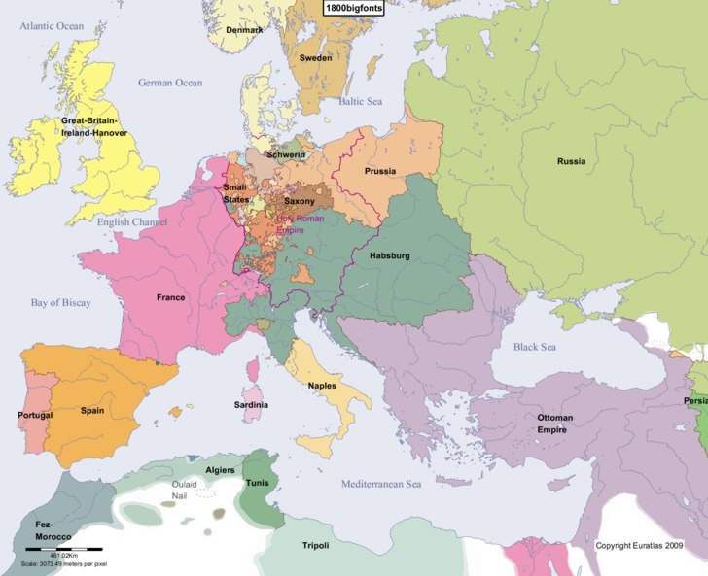
Europe, 1800

