Causes of WWII
Treaty of Versailles - Totalitarianism - Appeasement

Treaty of Versailles

- At the end of World War I, the victors (France, US, UK, and Italy) met to discuss peace terms that would repair Europe, limit the start of another war, and punish Germany. This document included 5 major points
  - Reparations – Germany had to pay millions of dollars for the damage caused by the war
  - Disarmament – Germany’s military was limited – no air force of submarines – very little army
  - Territory - land was taken away from Germany and given to other countries; alliance with Austria was forbidden
  - War Guilt Clause – Germany should accept the blame for WWI
- The harsh conditions imposed by the Treaty of Versailles after WWI helped lay the foundation for the rise of Nazism in Germany.
  - After dealing with an economic depression and loss of national pride, a leader who promised to return Germany to glory and prestige was much appreciated.

The Great Depression

- The Great Depression was a major factor causing people in Europe to question their new failing governments following WWI and eventually cause the rise of dictators.
  - Germany suffered the largest decline in production after WWI, leading to high inflation, unemployment, and economic crisis.
- Following World War I, overproduction led the world into a major economic depression.
  - In the U.S., farmers produced excessive amounts of food after the war, and during the 1920’s without high demand, a depression started.
  - Additionally, some banking policies were unsound, and led to the overexpansion of credit, which contributed greatly to the Great Depression.
  - Many countries felt a lack in national pride, struggled with starvation and unemployment, and hoped for change to come.

Totalitarianism

- Totalitarian dictatorships gained power in Europe between WWI and WWII new democracies failed to meet the demands of the people
  - Totalitarianism: a form of government where total political power is to be in the hands of a single person, or a particular class. This political system does not recognize the rights of the individuals and places no restrictions on the authority of the state.
  - Censorship, mass arrests, and a secret police force are most characteristic of totalitarian regimes.
  - The Great Depression led to a Totalitarian leader in Germany.

Fascism

- A totalitarian form of government with the ideology that the nation or race is kept above everything else.
- Fascism in Europe during the 1920's and 1930's can be best described as a political system that glorified the nation above the individual.
- Fascist governments have the following characteristics

  - Use of violence and terror
  - Blind loyalty to a leader
  - Censorship
  - Extreme nationalism
- In Europe during the 1920's and 1930's, extreme nationalism, belief in forceful leadership, high unemployment, and fear of communism all contributed to rise of fascist regimes in Italy, Germany, and Spain
  - Italy – Benito Mussolini
  - Japan – Hideki Tojo
  - Soviet Union – Joseph Stalin
  - Germany – Adolf Hitler
- One similarity between Adolf Hitler (Germany) and Benito Mussolini (Italy) is that both glorified violence.
  - Both Italy and Germany utilized secret police that arrested or beat up opposition or enemies of the government party. Fear and repression were foundations of both leaders’ rule.
Stalin

- Unlike many totalitarian leaders, Stalin was a communist.
  - One similarity between totalitarian systems like fascism and communism in the 1930's was that both systems generally suppressed opposition views.

- Under Stalin, Soviets experienced censorship, government control of industry, and religious persecution
  - One of Stalin’s major goals was industrialization and modernization to strengthen the international presence of the Soviet Union.
    - The economic policies of the Soviet Union under Stalin's "five year plan" traditionally emphasized the production of heavy industrial goods.
  - Under fascism, private property is accepted, whereas the government in a communist state owns all property and means of production.
    - The Soviet Union used collectivization to forcibly take over private land to create state-controlled farms.
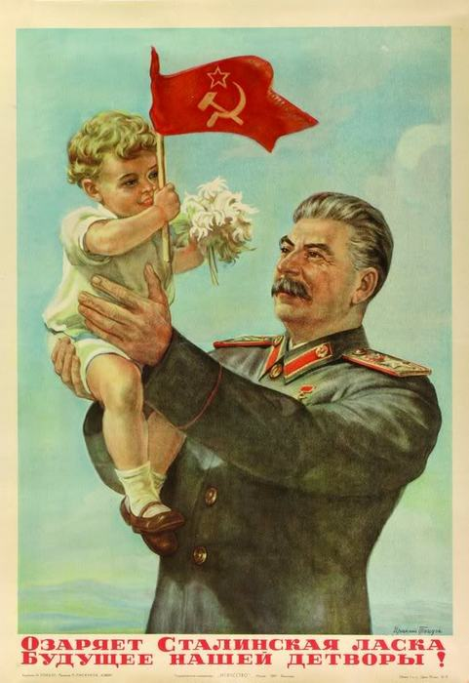
      - This meant that small farms would be gathered together to form one large massive one. These bigger farms would be called collectives. As they were large, there was every reason to use machinery on them. The more food that could be grown the better as the cities and factories could suitably be fed. Hungry factory workers would not be in a fit enough state to work effectively. If this happened the Five Year Plans would not succeed.
      - Villages who refused to collectivize were sent to prison camps.

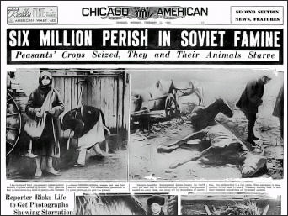

Hitler

- Adolf Hitler and the Nazi Party in Germany rose to power in the 1930s partly because of extreme hardship brought about by economic decline.
  - Like many totalitarian regimes, European demand for reform to save them from political and economic instability brought in strong, forceful leaders.
- A WWI veteran, Hitler had hopes to take over the government long before he succeeded. He was imprisoned when the Nazis attempted to seize the government in 1924. While in jail, he wrote his manifesto Mein Kampf which outlined his ideals for Germany.
  - Hitler’s Mein Kampf expressed prejudices about the Jews - which led to the murder of millions of European Jews during the Holocaust.
  - It also expressed his ideas about expanding the German empire to create living space for the master race he felt Germany and Austria made up.

In 1940, officials from Nazi, Germany, imperial Japan, fascist Italy, met to form the Berlin – Tokyo – Rome agreement, a military alliance forming the Axis Powers

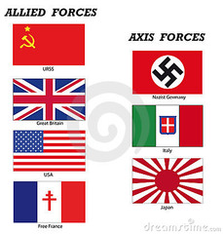
Axis Powers

Japan Italy Germany

Allies

USSR
Great Britain
USA
France

Appeasement

- Once Hitler came to power, he aimed to build the German living space, or ‘lebensraum’ by taking over lands, eliminating people he thought were of a lesser race, and moving Germans in.
  - He wanted to start with Austria, as he felt they were the closest ethnically to Germans. After successfully integrating Austria through a policy of Aunchluss, he moved on to his next target: the Sudetenland of Czechoslovakia.
- At the Munich Conference, Britain and France met with Germany to discuss Czechoslovakia’s fate. They gave in to Hitler’s demands.
  - Western democracies denounced the moves of Adolf Hitler but took no real action. Instead they adopted a policy of appeasement.
    - Appeasement: giving in to the demands of an oppressor
    - The "Munich mistake" refers to a policy of appeasement

- Just like giving in to a bully doesn’t work because they come back for more, Hitler wasn’t finished and hoped to move into Poland next.
  - Germany signed a non-aggression pact with the Soviet Union to avoid a war on 2 fronts – they secretly split Poland in half.

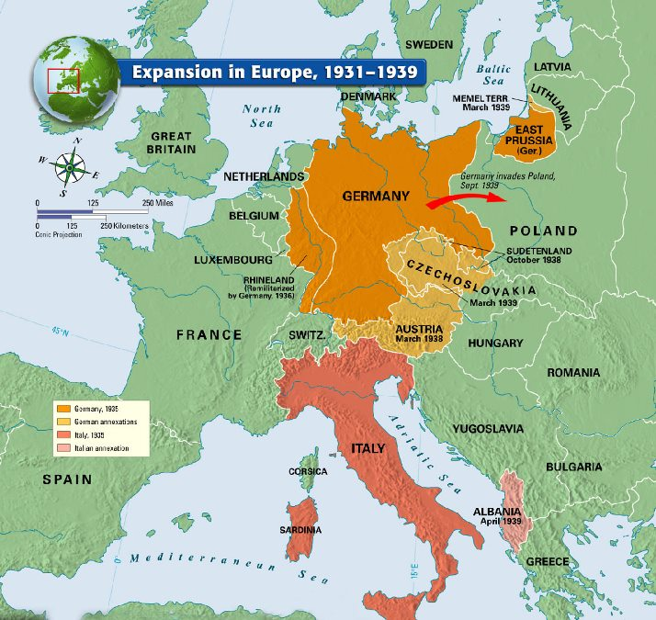
The German invasion of Poland led to the start of WWII, as Britain and France declared war on Germany.

Hitler used blitzkrieg to take Poland: fast surprise *lightening war* bomb attacks followed by tanks – using radio to coordinate moves carefully.

Japan's invasion of Manchuria, Italy's attack on Ethiopia, and Germany's blitzkrieg in Poland were examples of military aggression/expansion.

Battle of France

- Germany took France by invading the Low Countries (Belgium, Netherlands, and Luxembourg). France fell quickly and Hitler set up a puppet government in the south (put in a leader that would do whatever he said.)

Battle of Britain (1940)

- Hitler used air attacks to take out British military stations, but then turned to bombing cities to break the British morale. The British used radar to track incoming German planes, and saved their country from defeat.

Winston Churchill (leader of Great Britain) warned his countrymen about Adolf Hitler, rallied his country against German assaults, used radar to warn people of German attacks, refused to surrender, and worked closely with President Roosevelt.

Operation Barbarossa (1941/42)

- In defiance of the non-aggression pact, Hitler attacked the Soviet Union
  - Hitler hoped to gain land for the German people by attacking the Soviet Union
  - During a series of major battles, Hitler took ground from the Soviets. However, after many months in Russia’s border, Germany fought a war of attrition – to see how long they could last. They were losing men and supplies at an alarming rate, and eventually succumbed to the winter weather within the Soviet Union.

Holocaust

- Hitler felt that the Jewish people, as well as Romas, Slavs, homosexuals, and persons with disabilities, were of a lesser race and should be exterminated.
  - The Holocaust is considered a unique event in modern European history because the genocide was planned in great detail and required the cooperation of many people.
  - 6 million Jews, and 5 million others were murdered for the Nazi cause.
  - Hitler’s Final Solution included concentration camps, death camps, and Einsatzgruppen (a mobile killing squad).
    - Jews were taken from their homes, shipped to camps where they worked until they starved, or they were gassed and incinerated to ashes to eliminate evidence of the Nazi evil.
Japan

- In the 1930’s, Japan’s government followed a policy of imperialism primarily to acquire new sources of raw materials.
- The United States became involved in World War II primarily because Germany and Japan achieved important military successes in Europe and Asia
  - As many of their allies fought, the United States slowly became involved. After the attack at Pearl Harbor in Hawaii by Japanese troops, the United States became directly involved in the war effort.
- During World War II, many Japanese Americans living on the West Coast were relocated to detention centers primarily because they were seen as a security threat.
Japan resigns from the League of Nations
The Rome-Berlin-Tokyo axis is formed
Japan invades China
U.S. places embargo on scrap iron and oil exports to Japan
Pearl Harbor was Attacked by Japan
  - After the bombing of Pearl Harbor, racism against Japanese Americans was very strong, as their loyalties were questioned and they were seen as traitors by white America. Japanese Americans loving on the West Coast were forced to surrender their homes, businesses, and possessions, and forced to live in camps.
United States involvement

- At the beginning of World War II, national debate focused on whether the United States should continue the policy of isolationism.
  - Isolationism: remaining apart from the affairs of other countries, avoiding involvement
  - The U.S. displayed their isolationism, through the passage of a series of neutrality legislation forbidding arms sales to warring nations. .
    - The U.S. hoped to avoid a repetition of the events leading up to their involvement in World War I.
  - However, over time, the U.S. inched closer and closer to becoming involved by lightening the conditions for selling or lending weapons
  - The United States was called the “arsenal of democracy” in 1940 because the United States provided much of the weaponry needed to fight the Axis Powers.
- During World War II, many women experienced a change in role in that they worked in jobs formerly held by men.
  - While men were off fighting, women helped fuel the war effort but making munitions and supplies in the factories.

Pacific Front

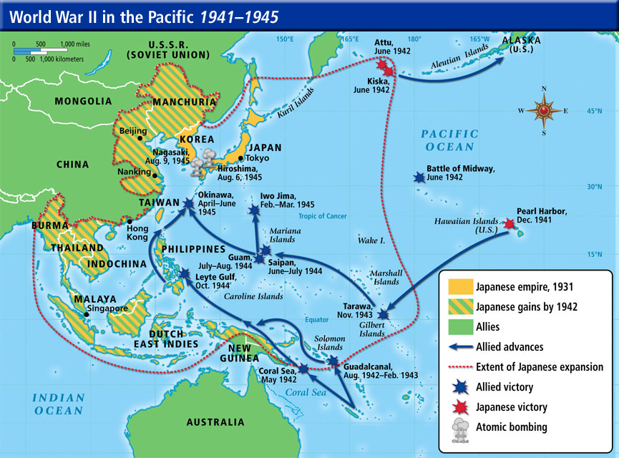
- General Douglas MacArthur used island hopping to battle Japan in the Pacific theatre.
  - Island hopping is the crossing of the Pacific Ocean by a series of shorter journeys between islands, as opposed to a single journey directly to the destination.
- Shortly after entering World War II, the United States began the Manhattan Project to work on the development of an atomic bomb.
  - They felt that if necessary, they may need to use it to end the war.
  - An atomic bomb can incinerate the surrounding area within a half-mile at temperatures up to 7,000 degrees Fahrenheit. The area surrounding would be destroyed from the fallout, and radiation would linger for months, causing disease and awful effects on those attacked.

- Truman’s fear of the number of Allied lives it would take to conquer the Japan mainland led to the decision to drop the atomic bombs on Japan.
  - Two bombs were dropped to force Japan’s absolute surrender: Fat Man and Little Boy in 1945 on Nagasaki and Hiroshima. They instantly killed 200,000 each at their drop bombs.
- A controversial issue that resulted from World War II was the morality of nuclear warfare
  - The world questioned whether or not it was the right choice to have destroyed these cities and killed so many innocent people became a big issue.

Aftermath of WWII

Nuremberg Trials
- The Nazi generals and officials that could be found and arrested (some escaped) were brought to trial for their crimes. Hitler committed suicide before being captured, so he wasn’t punished for his atrocious plans.
  - The Nuremberg trials are considered an important development in the rule of law because they established principles of responsibility for violations of human rights.
  - The war crimes trials of German and Japanese military officials following World War II established that individuals can be held responsible for wartime atrocities against civilians.

United Nations
- As World War II was ending, the United States decided to join the United Nations mainly because the United States recognized that efforts to achieve world peace required United States involvement.
  - After the failure of the League of Nations, which was unable to stop the outbreak of WWII, major world countries came together to codify terms of warfare and work together to avoid conflict.
- A host of nations banding together to stop an aggressor state could be considered collective security.

Superpowers

- As a result of WWII, two super powers emerged: United States and Soviet Union
  - Joseph Stalin was the leader of the USSR at the start of the Cold War.
- After World War II, the United States was better able than its allies to adjust its economy from wartime to peacetime because the United States had suffered no widespread wartime destruction.
  - Because of this, the United States became a super power in the world, along with the Soviet Union, who switched to the Allies side early on in the war.
    - Germany was divided into 4 sections, each controlled by one of the winners of the war: United Kingdom, France, Soviet Union, and the United States.
    - The United States established a long-term military presence in West Germany in an effort to stop communist expansion in Europe, along with the UK and France.
  - The Soviet Union was communist and hoped to spread communism -
    - Communist governments were established in most nations of Eastern Europe shortly after WWII because the Soviet Union used military and diplomatic pressures to install their governments

Iron Curtain

- Most Eastern European countries immediately after World War II became satellite nations of the Soviet Union.
  - A satellite nation is a nation that follows the lead of a major nation, without being taken over by that nation directly.

- The Cold War was the era of confrontation between the U.S. and USSR.
During the Cold War Era (1945-1990), the United States and the Soviet Union were reluctant to become involved in direct military conflict mainly because of global nuclear destruction.
- US presidents followed a policy of containment.
  - Containment: keeping communism within its present territory through the use of diplomatic, economic, and military actions, to limit the spread.

Truman Doctrine: 1947

- The US and Britain aimed to contain communism by supporting Turkey and Greece.
- The Truman Doctrine was a formal statement of intention of the United States to aid any country threatened by communist aggression.
  - a pledge on the part of the United States to help Greece and Turkey resist the spread of communism in the region
  - Truman asked for $400 million to fight communist aggression

Marshall Plan: 1947

- Post-war western Europe suffered many problems: economies were failing, people were starving, and political chaos took over.
- Senator George C. Marshall proposed the European Recovery Program that promised European nations American aid to rebuild their economies.
  - The purpose of the Marshall Plan was to help Western Europe recover
    - It pumped millions of dollars worth of supplies, machinery, and food into Western Europe – making communism less attractive and opening new trade markets.
Study Practice
- Adolf Hitler
- Franklin D. Roosevelt
- Hideki Tojo
- Winston Churchill
- Joseph Stalin
- Benito Mussolini
- Harry Truman

______1. Leader of Japanese troops who sponsored Japanese expansion

______2. Great Britain’s Prime Minister who warned against Hitler and promoted the use of radar during the Battle of Britain

______3. American President who approved the deployment of two atomic bombs in Japan

______4. Nazi party leader who discriminated against Jewish people

______5. Italian fascist leader who joined the Axis powers

______6. President who declared war against Japan after Pearl Harbor

______7. Leader of the Soviet Union who wanted to spread communism across Europe

Island hopping isolationism Warsaw United Nations Marshall

Munich Project Manhattan containment Nuremberg

9. As World War II was ending, the United States decided to join the
__________________________ mainly because the United States recognized that efforts to achieve world peace required United States involvement.
10. The U.S. displayed their __________________, through the passage of a series of neutrality legislation forbidding arms sales to warring nations.

11. The ____________________ trials are considered an important development in the rule of law because they established principles of responsibility for violations of human rights.

12. At the ________________ Conference, Britain and France met with Germany to discuss Czechoslovakia’s fate. They gave in to Hitler’s demands.

13. Shortly after entering World War II, the United States began the _________________________ to work on the development of an atomic bomb.

14. One reason the Soviet Union formed the ___________ Pact was to limit the threat of invasion from Western Europe.

15. General Douglas MacArthur used _________________________ to battle Japan in the Pacific theatre.

16. The purpose of the ________________ Plan was to help Western Europe recover and limit the spread of communism.

17. During the early years of the Cold War, presidents followed a policy of

_________________ to limit the spread of Communism.

